2. Create following tables «Warehouses» and «Packs»:

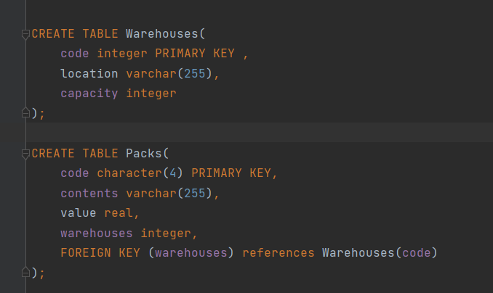

3. Inserting the content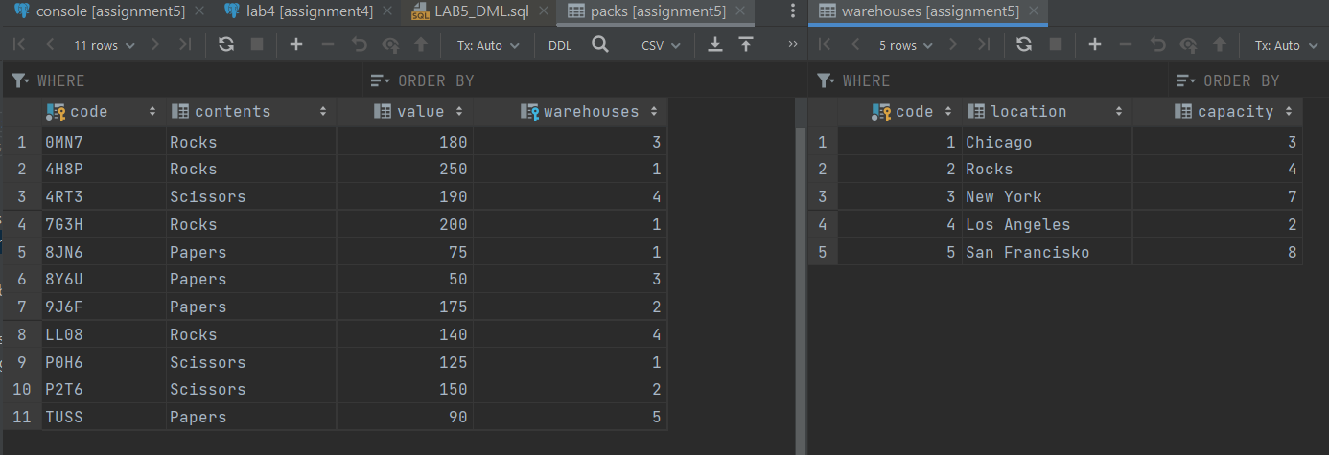

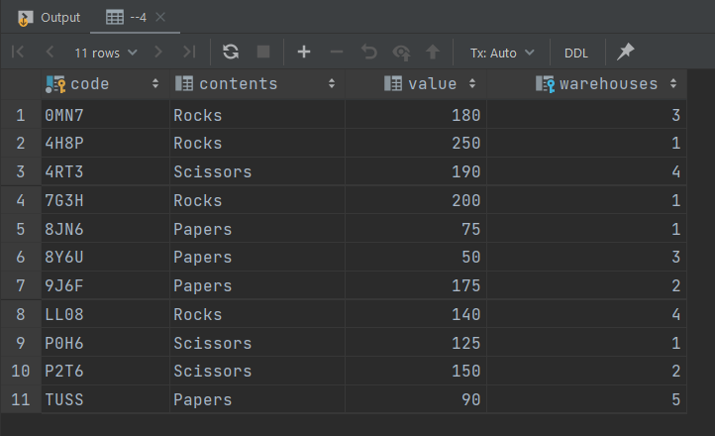4. Select all packs with all columns.

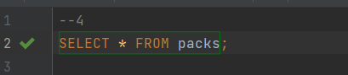

5. Select all packs with a value larger than $190.

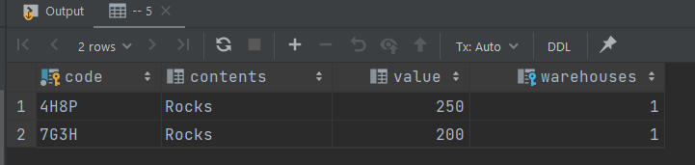

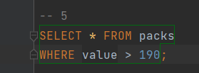

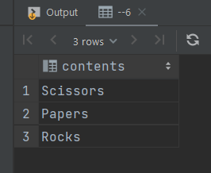6. Select all the packs distinct by contents.

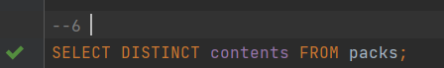

7. Select the warehouse code and the number of the packs in each warehouse.

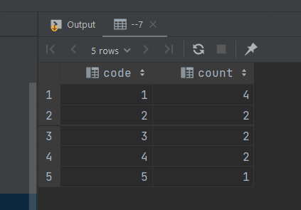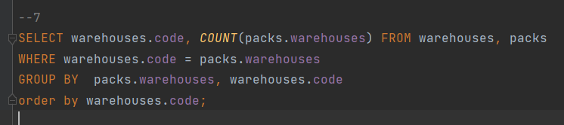

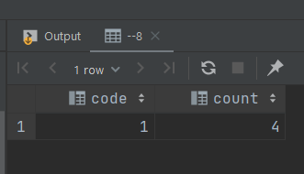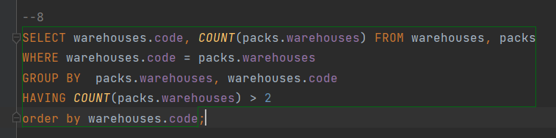8. Same as previous exercise, but select only those warehouses where the number of the packs is greater than 2.

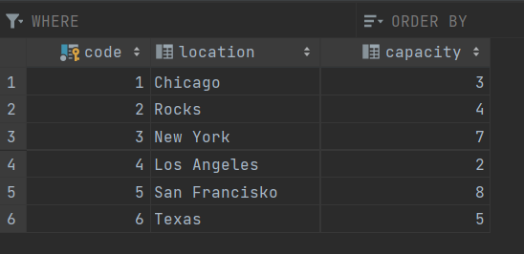9. Create a new warehouse in Texas with a capacity for 5 packs.

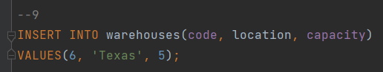

10. Create a new pack, with code "H5RT", containing "Papers" with a value of $150, and located in warehouse 2.

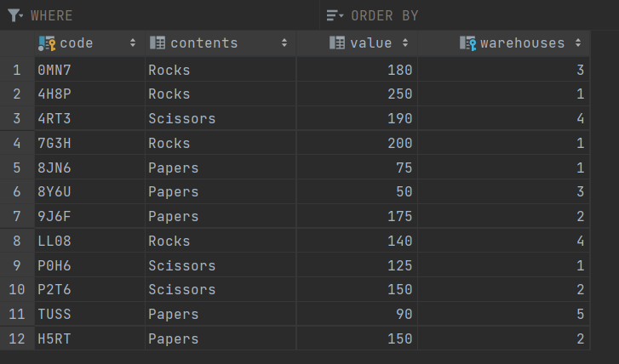

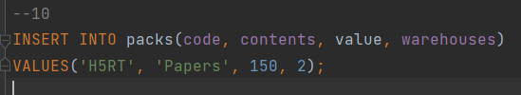

11. Reduce the value of the third largest pack by 18%.

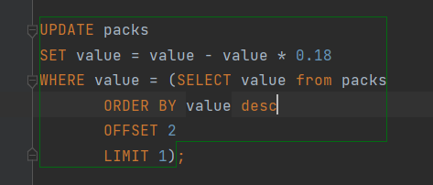

190 –> 155.8

`12. Remove all packs with a value lower than $150.

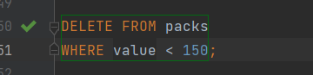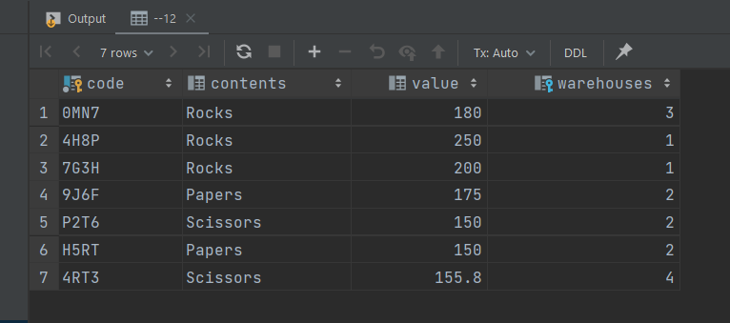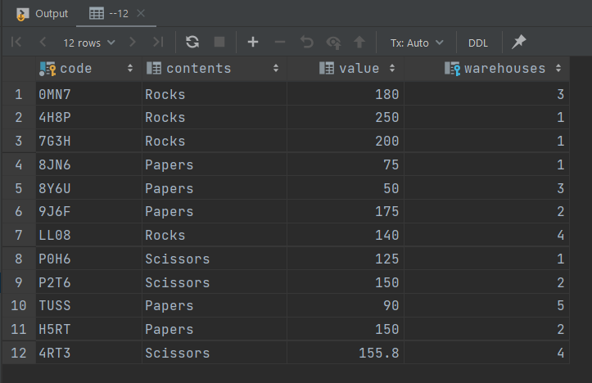

13. Remove all packs which is located in Chicago. Statement should return all deleted data.

